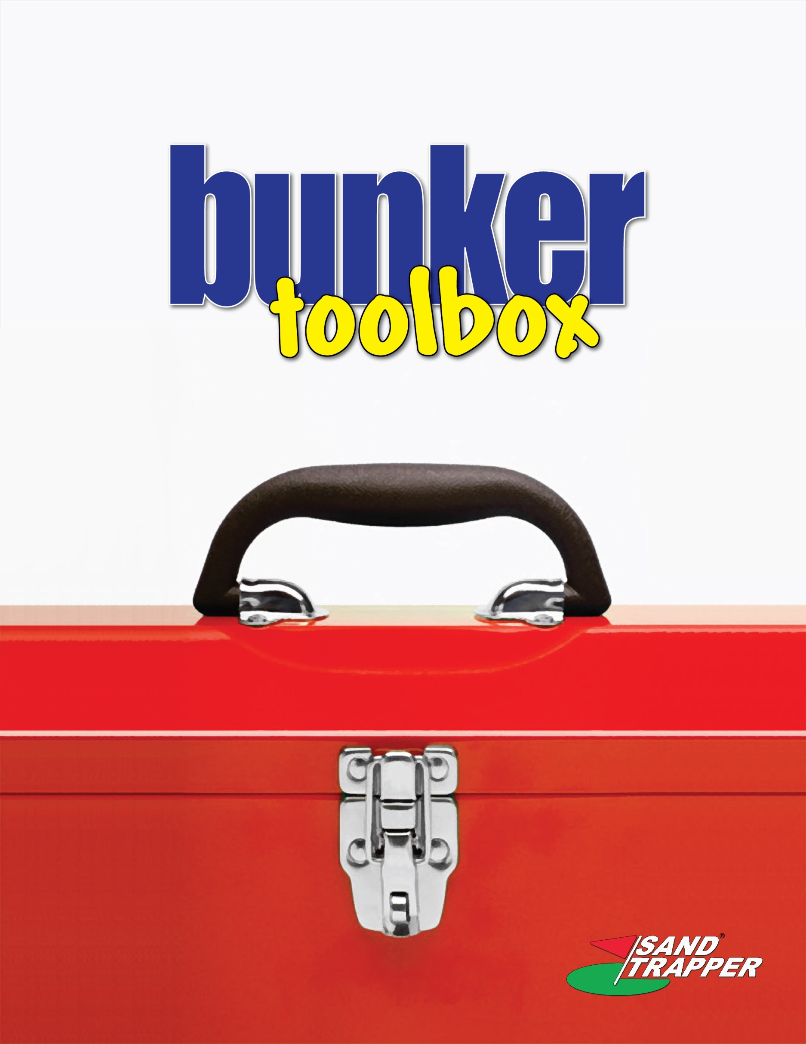

PROJECT ORGANIZATION
FILING SYSTEM & PROJECT MANUAL

FILING SYSTEM STRUCTURE

- General Correspondence
- Owner Contract
- Contract Summary
- Insurance Certificates, Bonds
- Roles & Responsibilities
- Payment Requests
- Incentives statusing
- Changes in Owner Contract
- Purchase Orders & Subcontracts
- Insurance Certificates/Bonds
- Payment Log
- Submittals in Process
- Submittals Approved
- Requests for Information in Process
- Requests for Information Finalized
- Engineering Correspondence
- Design Agreement
- Documents Status
- Billings/Payment
- Vendor Files (reports, submittals, evaluations)
  - Mechanical
  - Electrical
- Safety Plan - Meetings, Inspections, & Reports
- Quality Plan - Meetings, Inspections & Reports
- Progress Meetings, Reports
- Cost: Labor reports
- Equipment & Tool Reports (rentals & expendables)
- PO (Materials)/Contract (Subcontractor) Status Reports
- Field PO's
- Freight & Drayage
- Travel & Miscellaneous (shop visits, off-site meetings)
- Craftworker Recruitment, Training & Incentives
- Consultants (Labs, Form/Shoring Design, etc.)
- Cost to Complete
- Control Estimate
- Schedule Information
- Permits, Authorities, Inspections
- Independent Lab Tests & Reports
- Project Execution Plan
- Performance Criteria: Objectives/Evaluations
PROJECT MANUAL
Purpose:
To maintain a single bound document that includes the essential information for efficient management of production, communications, costs, physical resources, and finances for project success.
Responsibility:
Project Manager
When Required:
Initiate at the start of a project and maintain through completion of the project.
Scope:
See enclosures
Enclosures
The following describes the items, data, material, and information that is to be included in the Project Manual
NOTE: THIS IS A CONFIDENTIAL DOCUMENT AND IS "NEVER" TO BE TAKEN FROM THE CORPORATE OFFICE UNLESS ALL CONTRACTS AND PRICING INFORMATION IS REMOVED.

Section 1 - Production Control
- Schedule
  - Updated Start Schedule, when applicable
  - Updated Completion Schedule, when applicable
  - Updated Delivery and Installation Schedules
Note: JOB PROGRESS SCHEDULE WILL REMAIN UPDATED AND POSTED IN THE CONTROL BOOK.
- Meetings
  - Copy of current and previous two Main Office Job Progress Meeting Minutes, with summary sheet on top.
  - Copy of current plus previous two Job Progress Jobsite Subcontractor Meeting Minutes, when applicable.
  - Any other current meeting notes and/or minutes that document or describe problems or situations which may require attention.

- Procurement
  - Updated copy of status of Subcontracts. Use date of occurrence rather than a check mark to indicate action completed.

Section 2 - Cost Control
- Labor cost information The summary of labor cost for the most recent and two previous pay periods.
- Materials/Subcontracts Commitment Status The last month's Purchase Commitment Summary Report.
- Equipment The current copy of the construction manager's equipment charge report.
- Cost to Complete The most recent project manager's projected cost to complete summary.

Section 3 - Financial Control
- Invoicing. A copy of the last invoice submitted to the owner.
- Change order log. Copy of the current C/O Log
- Construction Cost Code Summary. Current copy of the Construction Cost Code Summary Report.
- Subcontractor Ledger Summary. Current copy of S/C Ledger Summary Report

Section 4 - Contracts
- Summary sheets. Summary of status of each subcontract amount and changes.
- Subcontracts & Purchase Orders. Alphabetical insertion of P.M.,'s copies of subcontracts, P.O.'s, and bonds. Each subcontract is to be preceded by the summary sheet.

Section 5 - Documentation:
- Project Manager's Project Summary Sheet (Subcontract Status)
        - Purpose. To be used as a guide to determine that most major areas of responsibility are being addressed.
        - Responsibility. Project Manager
        - When Required. Initially and for project's duration
        - Scope. Lists significant items, activities and milestones from start through completion of a project.
        - Action required.
          - Review periodically
          - List the date that each area of responsibility is completed.
          - Get results and do not procrastinate.
        - Forms: Project Control List
- Document control logs
- Requests and Changes Log
- Contract and P.O. Log.
- Submittals Log

