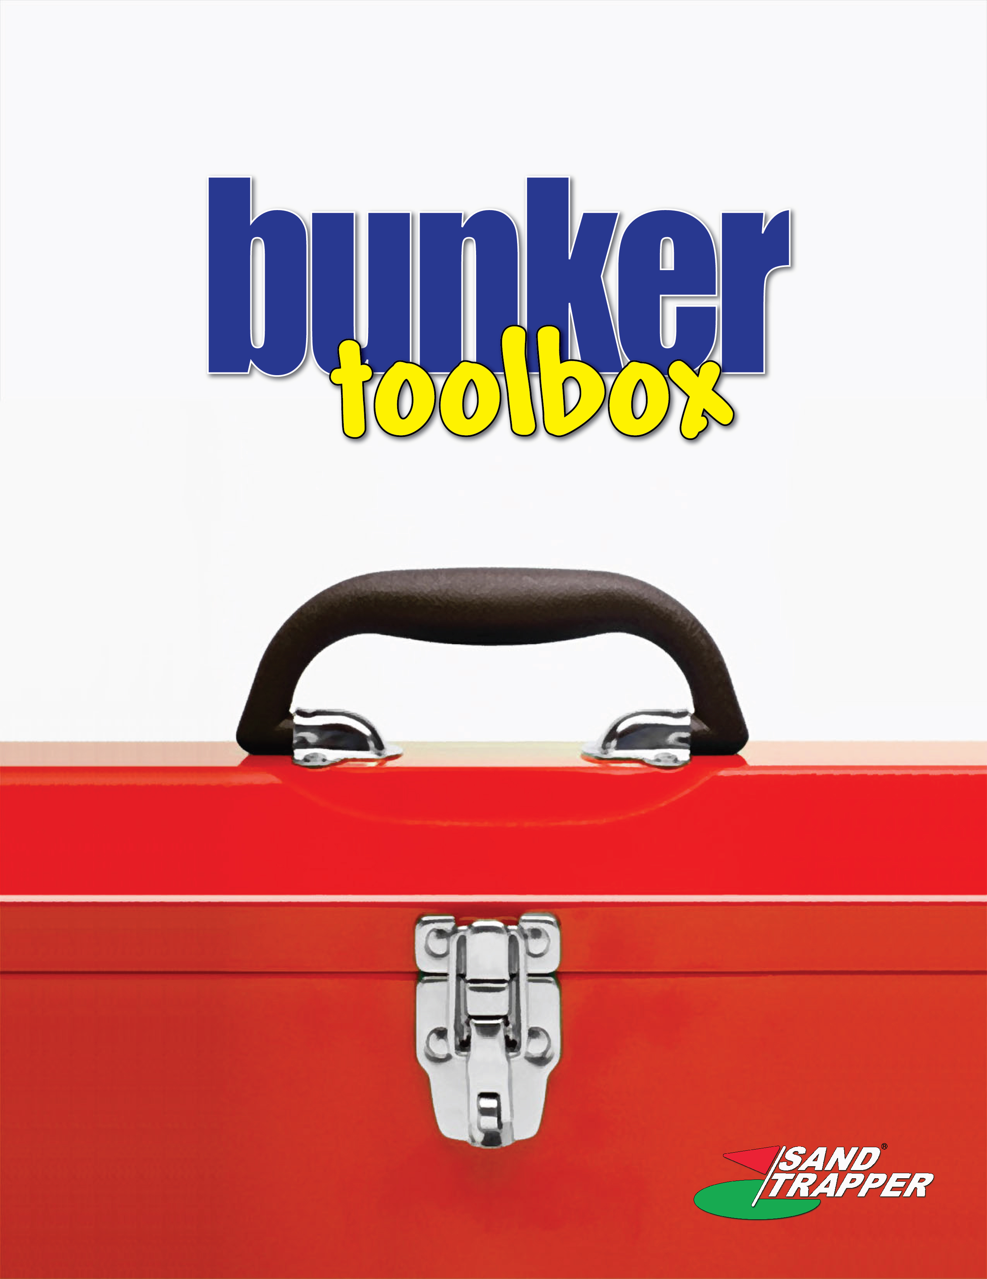

COMMUNICATIONS TEMPLATES

BUNKER PERFORMANCE & MAINTENANCE SURVEY

The following questionnaire is designed to assess your perceptions regarding the nature of bunkers, the condition of the bunkers on this course, the ability to maintain these bunkers, and the investment to improve the strategic/tactical characteristics of these bunkers.

This survey is not designed to be wholly scientific as it is to extract basic information from golfers and/or members. Once completed, you’ll be able to quickly tabulate responses and establish basic response averages. The survey is divided into three sections. The first is quantitative, with responses kept to pre-defined ranges. The second is qualitative, with questions requiring short responses. The third is for general comments about improving/changing bunkers on this course.

Part 1 – The following are statements about bunkers with which you will agree or disagree. Please indicate, on a scale of 1 to 10, your response to these statements.

Questions | <Disagree (circle one) Agree>
Questions | 1 | 2 | 3 | 4 | 5 | 6 | 7 | 8 | 9 | 10
- Bunkers are designed to be hazards and shouldn’t be maintained to the same level as putting greens. | 1 | 2 | 3 | 4 | 5 | 6 | 7 | 8 | 9 | 10
- Bunkers improve the strategic nature of golf. | 1 | 2 | 3 | 4 | 5 | 6 | 7 | 8 | 9 | 10
- Bunkers add aesthetic value to the design of the course. | 1 | 2 | 3 | 4 | 5 | 6 | 7 | 8 | 9 | 10
- The bunkers on this course have standing water in them after or during rain events. | 1 | 2 | 3 | 4 | 5 | 6 | 7 | 8 | 9 | 10
- The bunkers on this course have too many rocks, gravel and other foreign matter. | 1 | 2 | 3 | 4 | 5 | 6 | 7 | 8 | 9 | 10
- The bunkers on this course are too difficult to enter/exit when preparing/completing your shot. | 1 | 2 | 3 | 4 | 5 | 6 | 7 | 8 | 9 | 10
- The bunkers on this course washout after heavy rains. | 1 | 2 | 3 | 4 | 5 | 6 | 7 | 8 | 9 | 10
- The bunkers on this course are not a maintenance priority. | 1 | 2 | 3 | 4 | 5 | 6 | 7 | 8 | 9 | 10
- The bunkers on this course are too severe, too penal in strategic nature. | 1 | 2 | 3 | 4 | 5 | 6 | 7 | 8 | 9 | 10
- The bunkers on this course are old and overgrown. | 1 | 2 | 3 | 4 | 5 | 6 | 7 | 8 | 9 | 10
- The bunkers are the single most expensive feature on the course to maintain. | 1 | 2 | 3 | 4 | 5 | 6 | 7 | 8 | 9 | 10
- Sand replenishment is an effective alternative to bunker renovation. | 1 | 2 | 3 | 4 | 5 | 6 | 7 | 8 | 9 | 10
- Spending capital to improve bunker performance and save maintenance costs over the long haul is a worthwhile investment. | 1 | 2 | 3 | 4 | 5 | 6 | 7 | 8 | 9 | 10
- Re-designing bunkers to a different aesthetic is important. | 1 | 2 | 3 | 4 | 5 | 6 | 7 | 8 | 9 | 10
Part 2 – The following are questions about bunkers which will require a very brief answer. Keep your responses to just a few words. Part 3 will allow for more complete notes/comments.

Questions | Answers
- What is the number one problem/issue with the course bunkers?
- How often does the maintenance staff groom bunkers?
- Do you see the bunkers and their condition after heavy rain events?
- What 3 holes have bunkers in the poorest condition?
- Does this course use mechanical bunker rakes?
- In your estimate, how much does quality bunker sand cost per ton delivered?
- In your estimate, how much of the labor budget, as a percentage, does the course spend on bunkers?
- Do you believe there are bottlenecks during play that are attributable to course bunkers?
- If yes to question #8, what bunkers create bottlenecks?
- Is the image/reputation of your course important to you and the membership/golfer?
- In your estimate, how much does a bunker renovation cost for an 18-hole golf course?
- In your estimate, how many bunkers are on this course?
- In your opinion, are there bunkers on this course that have no strategic value to the game?
- Do you consider yourself to play well out of a bunker?
- During an average round, how many times do your shots wind up in bunkers?
- How much difference is there in bunkers from hole to hole, bunker to bunker?
- In your opinion, what course has the best bunkers, and why?
Part 3 – Answer the following question in one or two basic paragraphs. If you need more space, write on the back of this page.

Question – What would you do to improve the bunkers on this course and why?
BUNKER PROJECT MEMO 1

TO: Members & Golfers

FROM: Club Management & Maintenance Staff

RE: Strategic Bunker Renovation Planning

DATE:

In an effort to improve course conditions and maintenance costs, our club is currently evaluating a strategic bunker renovation project. Over the next few weeks, we will be around the course evaluating bunker conditions, maintenance routines, and playability concerns. We value you input as the improvements we are considering impact you and the quality of golf played at this facility.

We will be forming an internal management/project team that will be responsible for facilitating the evaluation process. The team will be comprised of persons from ownership, management, and members/golfers. We’ll be sure to notify you of the team members, when finalized.

One part of the evaluation process will be a Bunker Survey that will be distributed to all members/golfers for their input. It is a brief questionnaire that covers concepts related to our course bunkers and other general concepts. We ask for your honest opinions as all responses will be confidential. When the survey is distributed, it will contain instructions on where we will have them collected.

Moving forward, we will be determining the various methods and options available to improve our bunkers as an important course feature. We will closely analyze cost options and consider the right balance to achieve our objectives. We’ll be keeping you informed of many project related issues as we face them through periodic memos, signs, and posters around the club.

We thank you in advance for your involvement and contributions.

BUNKER PROJECT MEMO 2

TO: Members & Golfers

FROM: Club Management & Maintenance Staff

RE: Strategic Bunker Renovation Planning – Project Team Assignment

DATE:

We’ve completed the building of our Internal Project Team that will be responsible for facilitating the evaluation and planning process. As we move forward, we will be providing you correspondence and keeping you informed on a frequent basis. Should you have any questions or concerns, we would ask that you direct your communication to the member/golfer representatives as a first effort. Should you have an urgent need, feel free to speak to anyone on the team so we can address your concern.

Team Member | Title | Phone # | Email Address
BUNKER PROJECT MEMO 3

TO: Members & Golfers

FROM: Club Management & Maintenance Staff

RE: Renovation Planning – Project Update

DATE:

(( These are ideas for memos you’ll want to consider issuing as you progress through your project ))

Concept 1 – Architect & Builder Selection

Concept 2 – Budgeting Process

Concept 3 – Strategic Architecture Options

Concept 4 – Sand Selection

Concept 5 – Project Scheduling

Concept 6 – Course Rules & Guidelines During Construction

Concept 6 – Completion Events

